

THE RESEARCH AND INNOVATION FOUNDATION
SPONSROSHIPS ROGRAMME
EVENT IMPACT ASSESSMENT REPORT

EVENT DETAILS
TYPE OF ACTION | Event Category A ☐  Event Category B1 ☐  Event Category B2 ☐
PROGRAMME | SPOSNORSHIPS 2025  SPONSORSHIPS/EVENTS/0325
EVENT TITLE

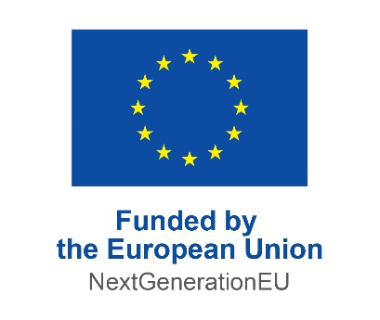 |  | 

The Cover Page, section headings and tables in this template must not be removed. Only guidelines in blue colour may be removed.

IMPACT ASSESSMENT REPORT

1. Call specific information
Date of event
Location of event
Total event budget
Number of participants from Cyprus
Number of participants from abroad
Number of distinguished speakers on R&I matters
Percentage of women speakers in the event, excluding moderators
Specific actions (choose all that apply) | ☐ Welcoming/keynote speech by the Chief Scientist for Research and Innovation of the Republic of Cyprus and/or a member of RIF’s Board of Directors and/or the Director General of RIF.  ☐ Panel discussion on a subject to be decided by the Chief Scientist / the RIF with a moderator and panel members to be defined by the Chief Scientist / the RIF or a RIF Info-Corner and/or session to present and promote the role of the RIF and its activities during the event.  ☐ A RIF kiosk on the premises where the event will be held, hosting two RIF staff members and startups or other entities funded by the RIF (only for Category A)  - Participation of at least 10 high risk investors from the Cyprus and the international ecosystem as well as successful serial entrepreneur (only for Category A)  ☐ Publicly acknowledgement of RIF’s funding  (Only for Category B1)  Participation of representatives at least from:  ☐ two publicly funded research organisations,  ☐three privately funded research organisations,  ☐ more than ten innovative existing companies and startups

2. Overview of activity
(Maximum Recommended 1 page)
Provide an overview of the event implemented, including key dates and describe the extent to which the event’s objectives were in line with the Sponsorships Programme objectives, as well as any conditions defined in the Call for Proposals. Mention the actions performed to mobilise the R&I ecosystem of Cyprus (mobilization and networking among members of the Cyprus R&I ecosystem, bringing together local and international entities and enterprises and/or supporting the development of R&I skills).

3. Impact assessment

(Maximum Recommended 1 page)
Please provide an overview of the impact of the event, including the following:
- event attendance, demographics and profile of event attendees and speakers (e.g. capital investors, serial entrepreneurs, representatives from research organisations etc),
- presentation of overall impact for the R&I ecosystem in Cyprus as a result of the event,
- description of media coverage and outreach (e.g. number of press releases, social media outreach etc.).

3. Analysis of Costs

DESCRIPTION OF EXPENSE | TOTAL COST | INITIAL BUDGET AS INCLUDED IN THE APPLICATION

(insert additional rows as appropriate)

4. Annexes

Please provide copies of the following documents:

Final Event Programme

Final List of Attendees/Proof of number of participants

Event promotional/informational material (e.g. press releases, posters, banners, social media posts, T-shirts etc.)

Event photos

Declaration of non-debts to State Authorities (if applicable)

The collection and processing of personal data by the Research and Innovation Foundation is carried out according to the Foundation’s Policy for the Protection of Personal Data, which can be found at the RIF’s website (www.research.org.cy).

Ι agree ☐

